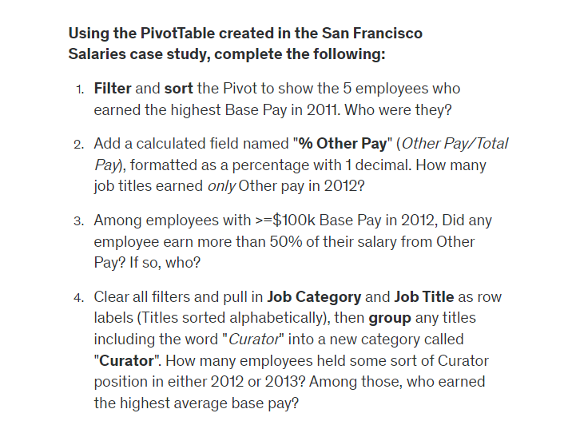

1. John J. Loftus, Naomi M Kelly, Barbara A Garcia, George Gascon, Kenneth A Lombardi

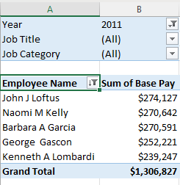

1. Total of 8

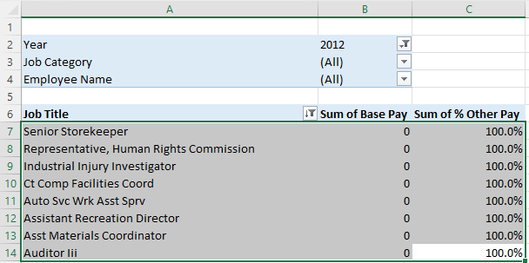

1. Anna L Cuthbertson

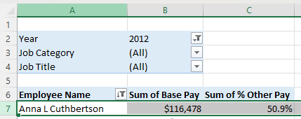

1. Total of 9 Employees